ZavaCore Fiber – Technical Specifications

## Materials and Construction

* 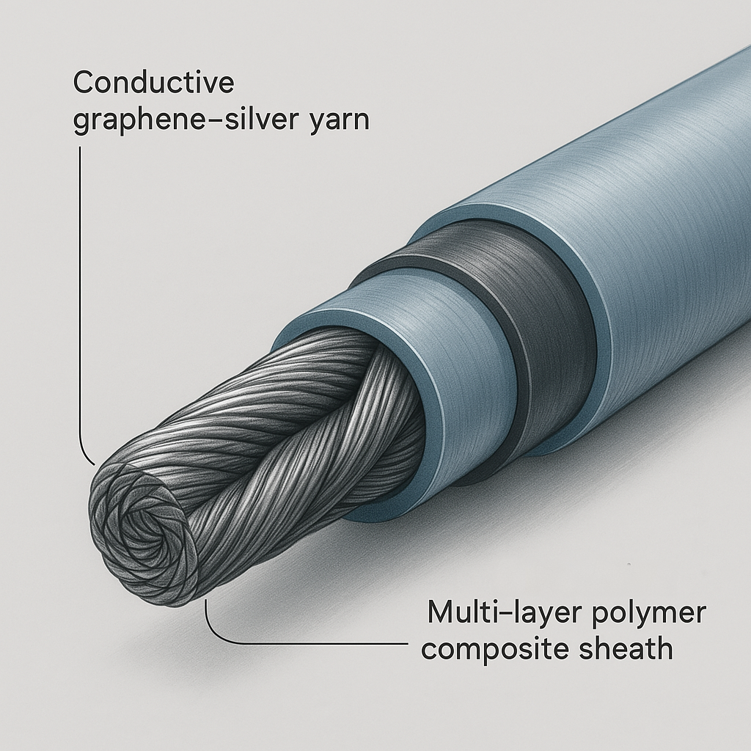Core Composition: Conductive graphene-silver yarn.
* Encapsulation: Multi-layer polymer composite sheath designed for insulation, flexibility, and biocompatibility.

## Mechanical Properties

* 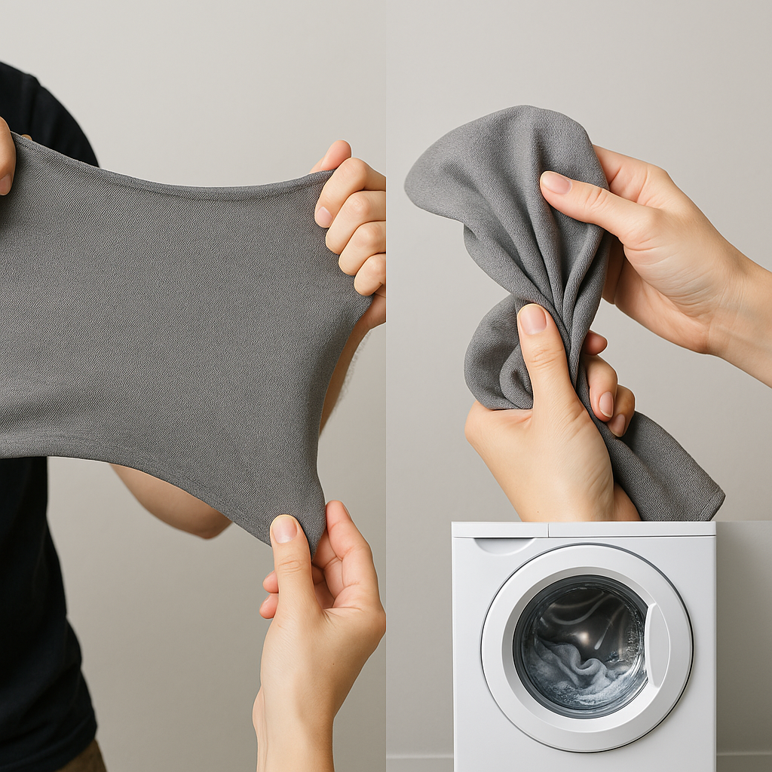Tensile Strength: Greater than 100 MPa.
* Flexibility: Maintains textile-like drape and stretch.
* Washability: Rated for over 50 machine wash cycles (gentle cycle).

## Embedded Sensors

## Biometric Sensors

* 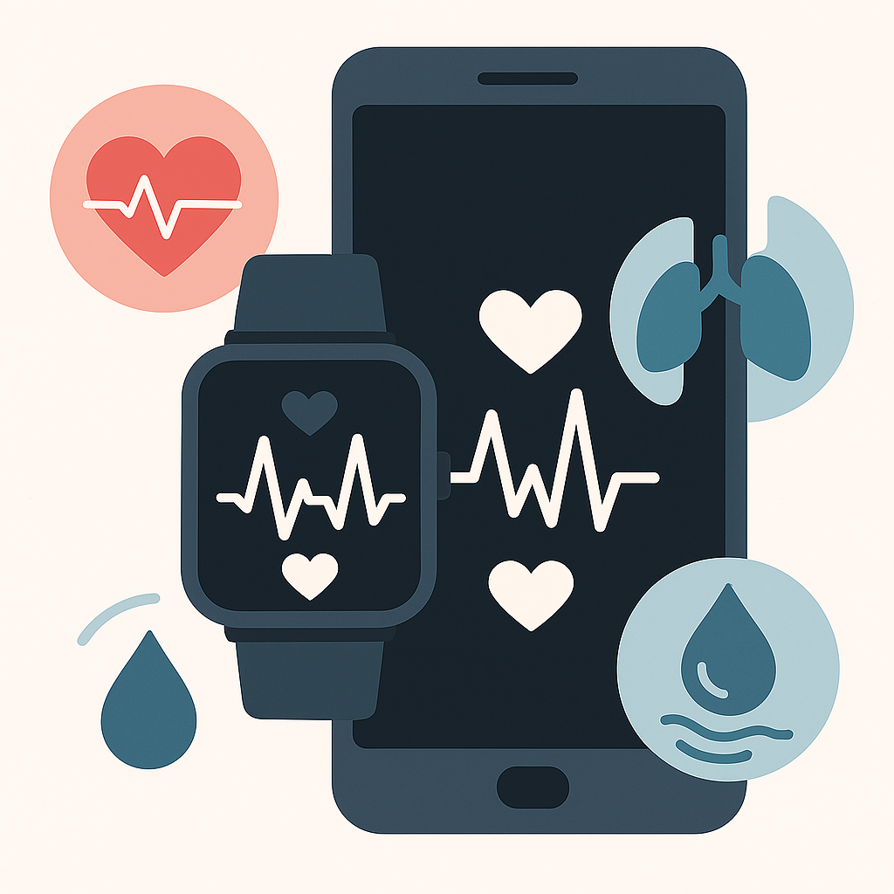ECG (Electrocardiogram): Provides monitoring for heart rate and rhythm.
* Respiratory Rate: Measures breath frequency via strain or impedance.
* Hydration: Bioimpedance-based sensor for skin hydration detection.

## Environmental Sensors

* 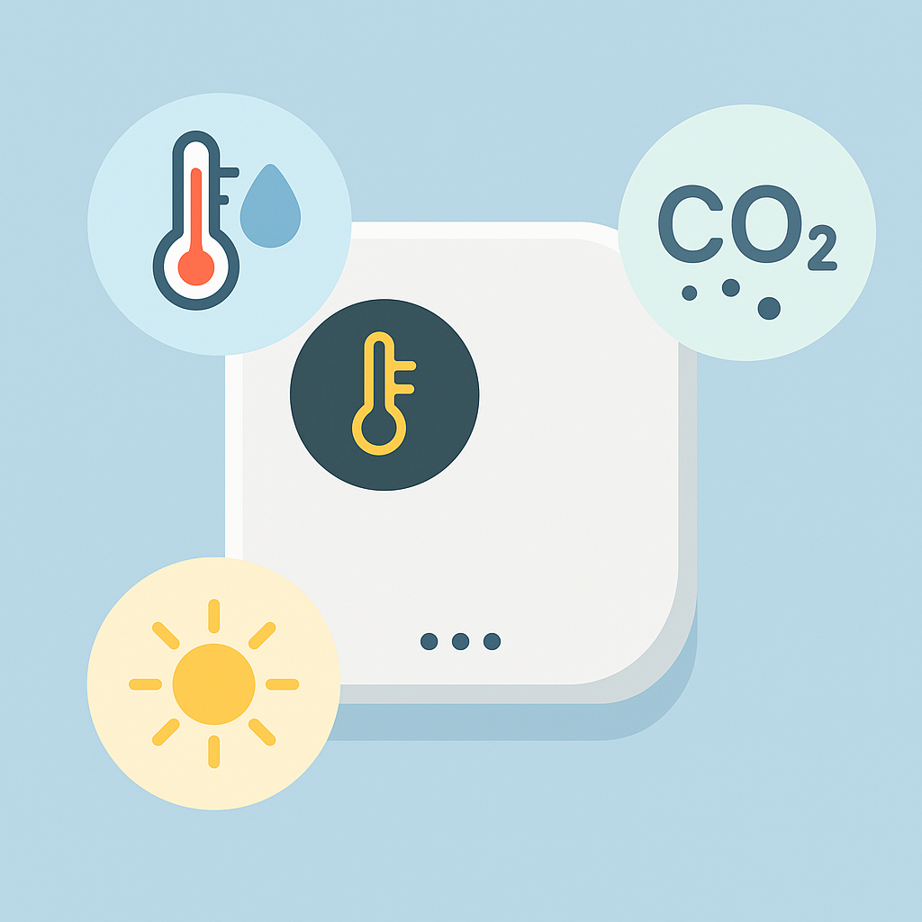Temperature and Humidity: Monitors atmospheric conditions.
* Air Quality: Includes VOC and CO₂ gas sensors.
* UV Exposure: Incorporates UV photodiodes for sun protection insights.

# On-Fiber Electronics

* Microcontrollers: Distributed low-power MCUs for signal conditioning and control.
* Edge AI: Integrated neural network accelerators designed for real-time inference; capable of detecting anomalies (e.g., arrhythmias, falls) within 2 seconds.
* Memory: Flash storage with several megabytes capacity for offline data buffering.

# Connectivity Features

* 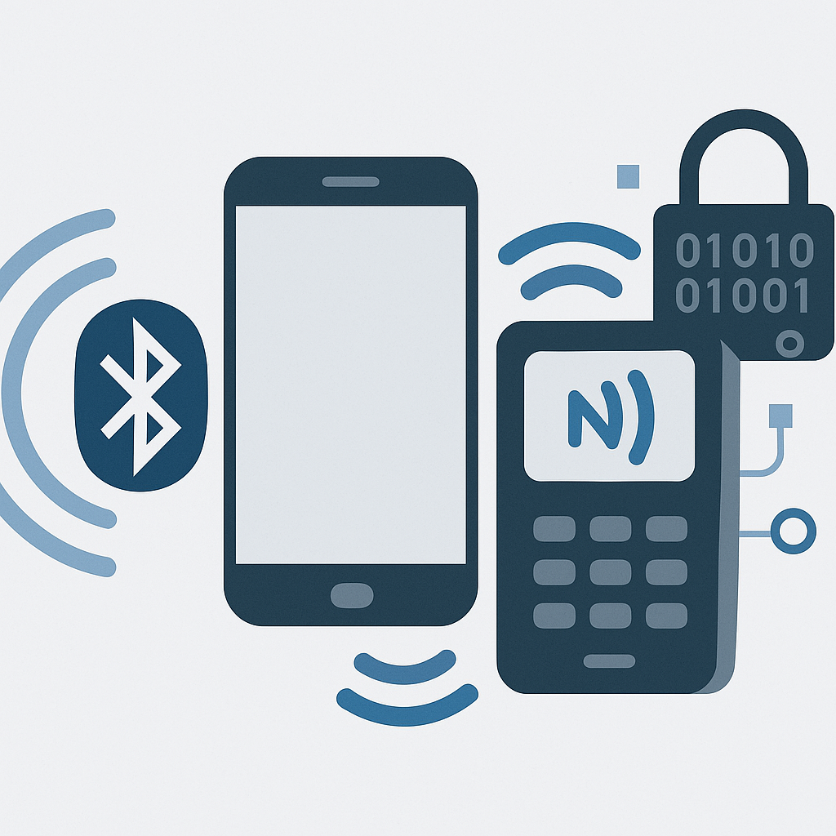Bluetooth Low Energy (BLE) 5.2: Achieves a range of approximately 10 meters and a data rate of up to 2 Mbps; allows continuous sync with smartphones and IoT hubs.
* Near Field Communication (NFC): Supports tap-to-transfer, authentication, or device pairing.
* Security: Includes AES-128 encryption for all wireless transmissions.

# Power System

* Primary Power: Thin-film Li-ion micro-battery integrated within garment seams or hems.
* Energy Harvesting: Features thermoelectric generators that convert body heat to electricity and piezoelectric strips that harvest energy from motion and fabric flexing.
* Battery-Free Operation: Feasible in low-duty-cycle scenarios relying solely on harvested energy.

# Data Processing

* On-Fiber Edge AI: Enables local processing to reduce latency and bandwidth needs; transmits only critical events or summaries.
* Latency: Less than 2 seconds for detecting critical events.
* Offline Mode: Stores data locally until a wireless connection is re-established.

# Durability and Safety

* Water Resistance: Utilizes waterproof polymer encapsulation.
* Washability: Certified for over 50 gentle machine wash cycles.
* Biocompatibility: Manufactured with hypoallergenic, latex-free materials.
* Regulatory Compliance: Designed in accordance with FCC (U.S.) and CE (Europe) standards; supports ISO 10993 and HIPAA-compliant data handling.

# Integration and Manufacturing

* 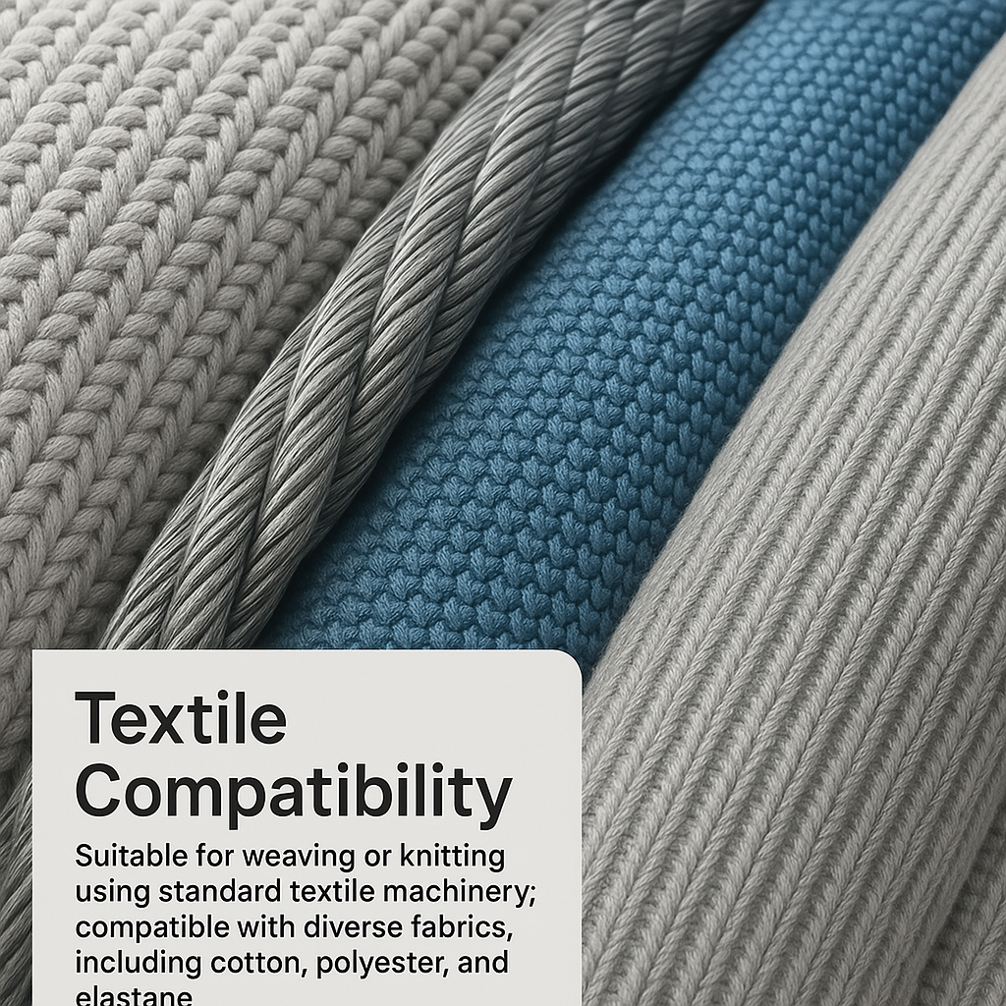Textile Compatibility: Suitable for weaving or knitting using standard textile machinery; compatible with diverse fabrics, including cotton, polyester, and elastane.
* Form Factor: Thread-like design that is flexible, soft, and virtually undetectable in finished garments.